**Kubernetes Case Study**

1. Setup minikube for Kubernetes on local machine and install Docker Desktop App for further steps.
2. Once installed and setup, start minikube by passing minikube start command.

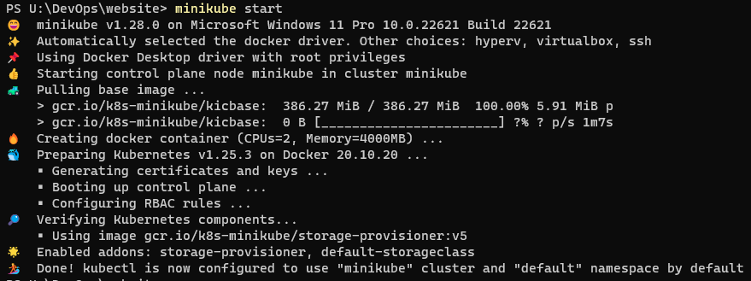

1. Create a yaml file for apache deployment : apache-deployment.yaml

apiVersion: apps/v1

kind: Deployment

metadata:

name: apache-deployment

spec:

replicas: 2

selector:

matchLabels:

app: apache

template:

metadata:

labels:

app: apache

spec:

containers:

- name: apache-container

image: httpd:latest

ports:

- containerPort: 80

1. To apply the deployment pass the command : kubectl apply -f apache-deployment.yaml

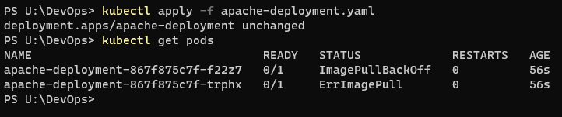

1. Once the deployment is applied, we can now proceed with cloning the github repo : git clone <https://github.com/hshar/website.git>

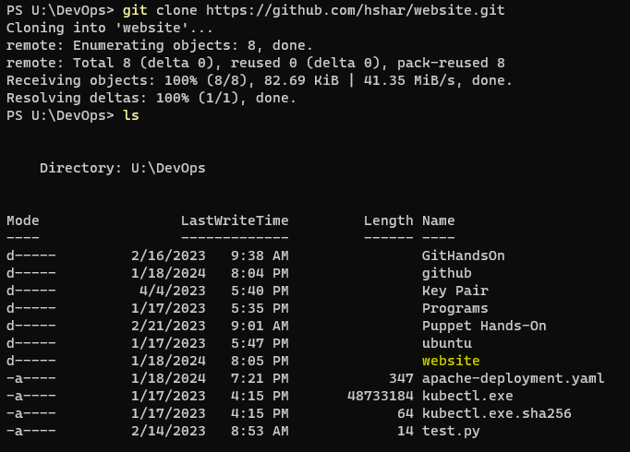

1. Once it’s cloned, move inside the website folder by passing cd website command
2. Build a Dockerfile with the below content.

FROM node:14

WORKDIR /app

COPY package*.json ./

RUN npm install

COPY . .

EXPOSE 3000

CMD ["node", "app.js"]

1. Build the dockerfile by passing docker build -t website:latest .

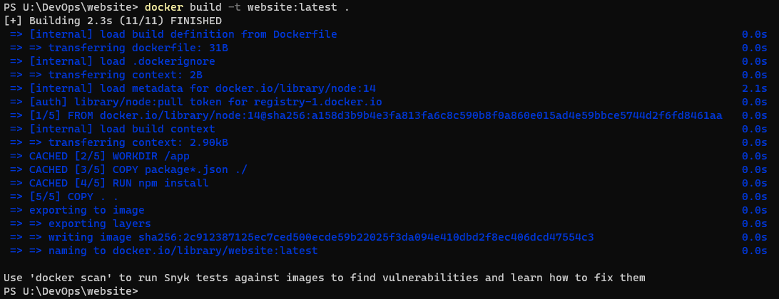

1. Now create deployment for GitHub Application

apiVersion: apps/v1

kind: Deployment

metadata:

name: github-app-deployment

spec:

replicas: 2

selector:

matchLabels:

app: github-app

template:

metadata:

labels:

app: github-app

spec:

containers:

- name: github-app-container

image: website:latest

ports:

- containerPort: 3000

1. Apply the deployment.yaml by passing kubectl apply -f github-app-deployment.yaml command.

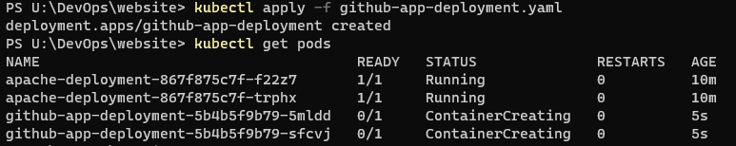

1. Once this is done, create a ingress.yaml file for the rules

apiVersion: networking.k8s.io/v1

kind: Ingress

metadata:

name: my-ingress

spec:

rules:

- host: minikube.local

http:

paths:

- path: /apache

pathType: Prefix

backend:

service:

name: apache-deployment

port:

number: 80

- path: /custom

pathType: Prefix

backend:

service:

name: github-app-deployment

port:

number: 3000

1. To apply the deployment pass the command : kubectl apply -f ingress.yaml



1. Access the Applications: Open your web browser and access the applications using:
   1. Apache: <http://minikube.local/apache>
   2. GitHub Application: http://minikube.local/custom